
COLLEGE OF NATURAL AND COMPUTATIONAL SCIENCES
MASTERS OF SCIENCE IN BIOINFORMATICS
Data science and cloud computing for Bioinformatics

Analyzing a Published Biological Dataset
Using the Data Science Workflow
Case Study: RNA-seq Analysis of pasilla (NOVA1/NOVA2 ortholog) Knockdown in Drosophila melanogaster
GEO Accession: GSE18508
Source study: Brooks AN, Yang L, Duff MO, et al. (2011). Conservation of an RNA regulatory map between Drosophila and mammals. Genome Research, 21(2), 193–202
Assignment 1
Name: Tsion Legesse
ID No: GSR/1433/18
Department: MOLECULAR SCIENCE AND GENETICS
Course Code: BINF6162
Nigatu (PhD)
September,15,2026

OVERVIEW
This report applies the standard data science workflow to a single, published, publicly available bioinformatics dataset: the pasilla RNA-seq dataset generated by Brooks et al. (2011) and deposited in the NCBI Gene Expression Omnibus (GEO) under accession GSE18508. The dataset is one of the most widely used teaching and benchmarking datasets in RNA-seq differential expression analysis . it underlies the official Bioconductor ‘pasilla’ experiment-data package and is the worked example in the DESeq2 and DEXSeq vignettes. The ten sections below walk through the workflow end to end: from the biological research question, through data sourcing, cleaning, exploratory analysis, statistical modeling, visualization, biological interpretation, and finally the limitations of the study.
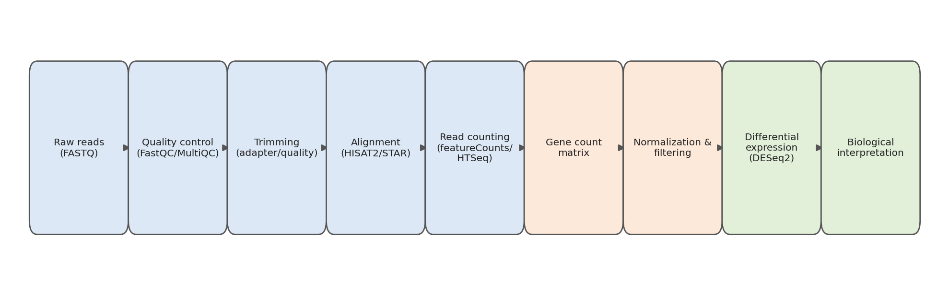
Figure 1. The end-to-end RNA-seq bioinformatics workflow applied in this report, from raw reads to biological interpretation
1. Research Question
Pasilla is the Drosophila melanogaster ortholog of the mammalian splicing factors NOVA1 and NOVA2, which are known regulators of alternative splicing in the mammalian nervous system. Brooks et al. (2011) set out to test whether the RNA regulatory network controlled by pasilla in flies is evolutionarily conserved with the network controlled by its mammalian counterparts.
The core research question addressed by the dataset is:
- Which genes change in expression, and which exons are differentially spliced, when pasilla is depleted by RNA interference (RNAi) in Drosophila cells, and do the affected genes/splicing events overlap with those regulated by NOVA1/NOVA2 in mammals?
For the purposes of this workflow report, the question is narrowed to the differential gene expression component: which genes are significantly up- or down-regulated between pasilla-depleted (treated) and control (untreated) Drosophila samples, and what does that reveal about pasilla's regulatory role?
2, Data Source
Repository and accession
The dataset is publicly archived in the NCBI Gene Expression Omnibus (GEO) under Series accession GSE18508. Raw sequencing reads are additionally available from the NCBI Sequence Read Archive (SRA), and a cleaned, ready-to-use version of the processed gene-level count matrix is distributed as the Bioconductor experiment-data package ‘pasilla’, making the data highly accessible for reproducible re-analysis.
Associated publication
Brooks AN, Yang L, Duff MO, Hansen KD, Park JW, Dudoit S, Brenner SE, Graveley BR (2011). “Conservation of an RNA regulatory map between Drosophila and mammals.” Genome Research, 21(2):193–202.
Access method
The processed count matrix and sample metadata can be obtained in R/Bioconductor via the pasilla package (system.file("extdata", "pasilla_gene_counts.tsv", package = "pasilla")), or downloaded directly from the GEO Series page and the SRA Run Selector for the raw FASTQ files.
3, Data Type
The dataset is bulk RNA sequencing (RNA-seq) data, a high-throughput sequencing-based measurement of gene expression. Several data layers are involved:
- Raw data: FASTQ files containing millions of short sequencing reads (some single-end, some paired-end) per sample.
- Intermediate data: BAM alignment files mapping reads to the Drosophila melanogaster reference genome (originally aligned with TopHat/Bowtie).
- Processed data: a gene-level count matrix — a table of non-negative integers where rows are genes (FlyBase gene IDs, e.g., FBgn0000017) and columns are the seven samples, with each cell holding the number of reads assigned to that gene in that sample.
- Metadata: a sample annotation table describing experimental condition (treated vs. untreated), library type (single-end vs. paired-end), sequencing lane, and total read counts per sample.
This report works primarily with the processed gene-count matrix, which is the standard starting point for differential expression analysis

4, Data Collection Type
The experiment used RNA interference (RNAi) to knock down the pasilla gene in Drosophila melanogaster S2-DRSC cells, comparing them against untreated control cells. Seven independent biological samples were profiled in total — four untreated controls and three pasilla-knockdown replicates.
Libraries were sequenced on the Illumina Genome Analyzer II. Two of the treated and two of the untreated samples were generated using a paired-end protocol, while the remaining samples used a single-end protocol, and sequencing was distributed across multiple lanes with varying read depth. After sequencing, reads were aligned to the Drosophila reference genome (Ensembl BDGP5 assembly) using TopHat, and reads were then summarized into per-gene counts using the exon annotations from the corresponding Ensembl GTF file..
Table 1. Sample design for the pasilla RNA-seq experiment (GSE18508).

Sample | Condition | Library type | Biological replicate
untreated1 | Untreated control | Single-end | 1
untreated2 | Untreated control | Single-end | 2
untreated3 | Untreated control | Paired-end | 3
untreated4 | Untreated control | Paired-end | 4
treated1 | Pasilla knockdown (RNAi) | Single-end | 1
treated2 | Pasilla knockdown (RNAi) | Paired-end | 2
treated3 | Pasilla knockdown (RNAi) | Paired-end | 3

5, Data cleaning steps
Turning raw sequencing reads into an analysis-ready count matrix, and then preparing that matrix for statistical testing, involves several cleaning stages:

5.1 Upstream (read-level) cleaning
- Quality assessment of raw reads (e.g., FastQC) to check per-base quality scores, GC content, adapter contamination, and duplication levels.
- Adapter and low-quality base trimming to remove sequencing artifacts before alignment.
- Alignment filtering to retain only reads that map uniquely and confidently to the reference genome, discarding multi-mapped or unmapped reads.

5.2 Downstream (count-matrix) cleaning
- Merging per-sample count files into a single gene × sample matrix and matching column names exactly to the sample metadata table.
- Verifying that the sample order in the count matrix matches the sample order in the metadata (a common and consequential source of silent errors in RNA-seq pipelines).
- Removing or flagging genes with zero counts across all seven samples, since these carry no information for differential expression testing.
- Filtering very low-count genes (e.g., requiring a minimum total or per-group count) to reduce noise and the multiple-testing burden before statistical modeling.
- Encoding condition and library type as categorical factors (untreated/treated; single-end/paired-end) rather than free text, so they can be used correctly in the statistical model.
As a concrete illustration, Table 2 shows a real excerpt of six genes from the published count matrix before any filtering. Note gene FBgn0000003, which has zero counts in six of seven samples — exactly the kind of low-information gene that would be filtered out prior to modeling.
Table 2. Excerpt of the raw gene-count matrix (GSE18508 / pasilla package).

Gene ID | untreated1 | untreated2 | untreated3 | untreated4 | treated1 | treated2 | treated3
FBgn0000003 | 0 | 0 | 0 | 0 | 0 | 0 | 1
FBgn0000008 | 92 | 161 | 76 | 70 | 140 | 88 | 70
FBgn0000014 | 5 | 1 | 0 | 0 | 4 | 0 | 0
FBgn0000015 | 0 | 2 | 1 | 2 | 1 | 0 | 0
FBgn0000017 | 4664 | 8714 | 3564 | 3150 | 6205 | 3072 | 3334
FBgn0000018 | 583 | 761 | 245 | 310 | 722 | 299 | 308

6, Exploratory Analysis
Before formal statistical testing, exploratory data analysis (EDA) is used to understand the overall structure of the dataset and catch problems early:
- Library size comparison: total read counts per sample are compared to check for large discrepancies in sequencing depth that would require normalization.
- Distribution checks: count distributions are highly skewed (many low counts, a few very high counts), motivating a log or variance-stabilizing transformation for visualization and clustering.
- Sample correlation / clustering: pairwise correlation heatmaps and hierarchical clustering on transformed counts are used to check whether replicates from the same condition cluster together.
- Principal Component Analysis (PCA): the first principal component is expected to separate treated from untreated samples if the treatment has a strong transcriptome-wide effect; additional components often reflect library type (single-end vs. paired-end) as a secondary source of variation.
- Outlier detection: any sample that fails to cluster with its biological group, or that has a markedly different library size or count distribution, is flagged for closer inspection.
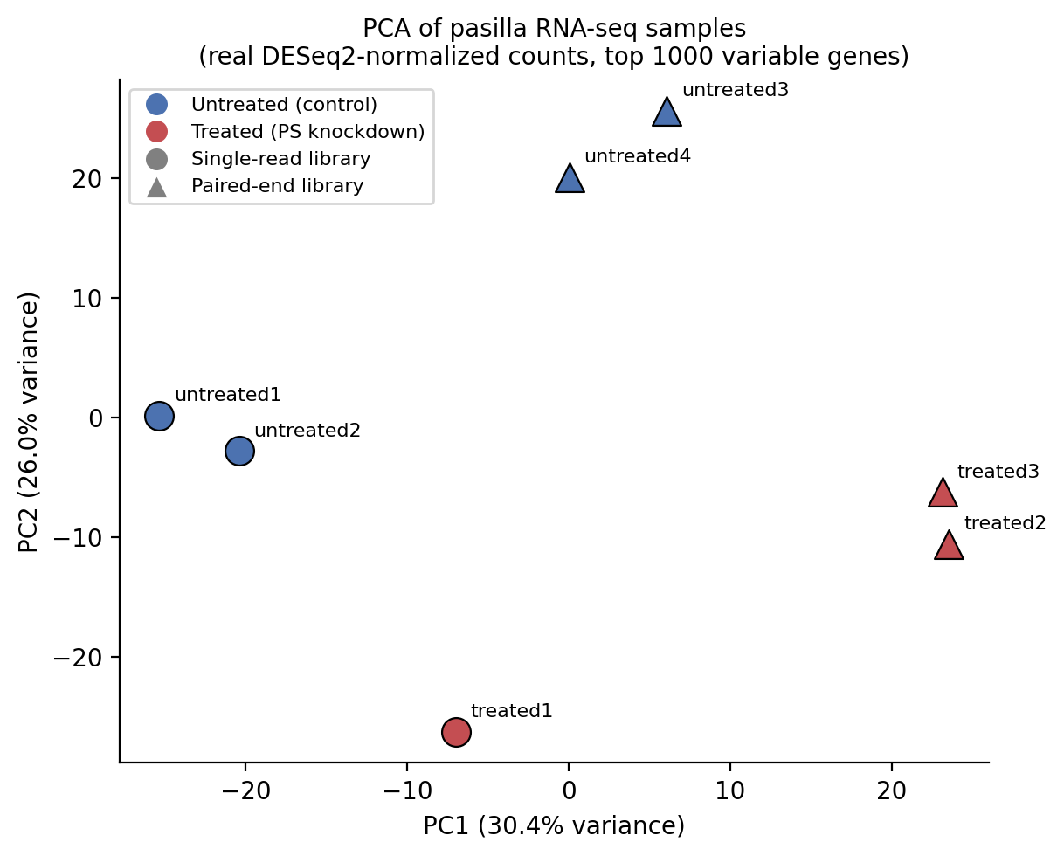
shows real raw counts (no normalization applied) for one gene, FBgn0000017, across all seven samples, as an early single-gene sanity check consistent with the genome-wide pattern confirmed later by the formal statistical test.
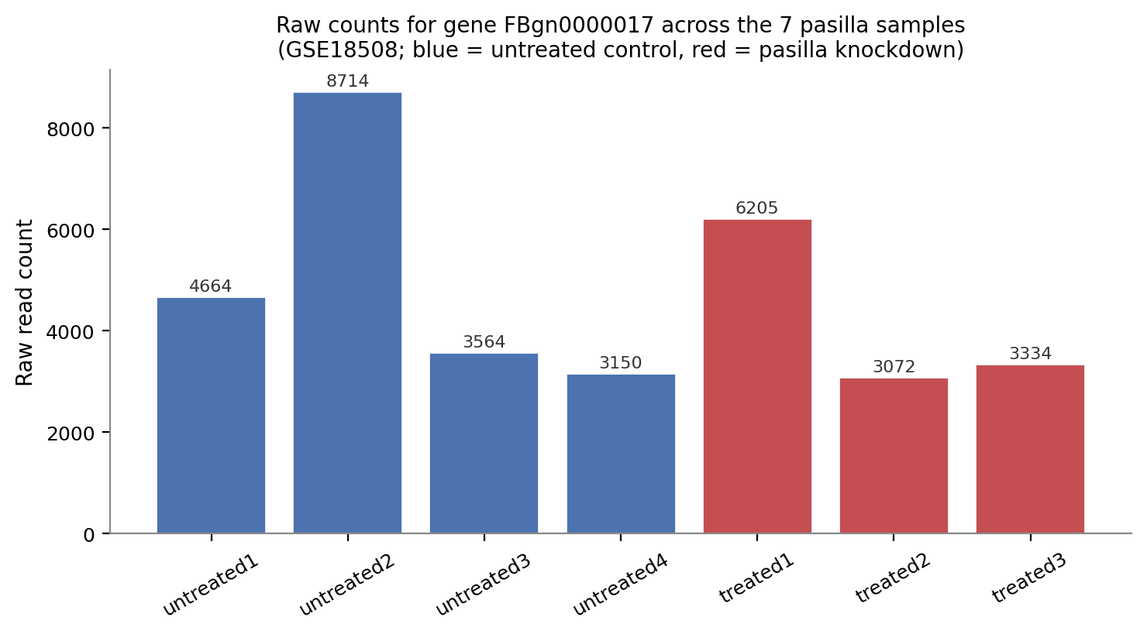
Figure 2. Raw read counts for gene FBgn0000017 in each of the seven samples (real values from the published count matrix).

7, Analysis or Modeling Method
The standard and most appropriate modeling approach for this type of count-based RNA-seq data is negative-binomial generalized linear modeling, as implemented in tools such as DESeq2 or edgeR (this dataset is, in fact, the canonical worked example in the DESeq2 vignette).

7.1 Why negative binomial, not linear regression
RNA-seq counts are non-negative integers with variance that grows with the mean (overdispersion) faster than a Poisson model would predict, so a negative binomial distribution is used to model gene-wise counts, with dispersion parameters estimated by borrowing strength (shrinkage) across genes to stabilize estimates from small sample sizes.

7.2 Modeling steps
- Construct a design formula, typically ~ type + condition, so that library type (single-end vs. paired-end) is controlled for while testing the effect of condition (treated vs. untreated).
- Estimate size factors to normalize for differences in sequencing depth between samples (median-of-ratios normalization in DESeq2).
- Estimate gene-wise dispersion, shrinking extreme per-gene estimates toward a fitted mean-dispersion trend.
- Fit the negative binomial GLM per gene and test the coefficient for the condition term using a Wald test (or a likelihood ratio test for more complex designs).
- Adjust p-values for multiple testing across all genes using the Benjamini-Hochberg procedure to control the false discovery rate (FDR).
Rank and shortlist genes by adjusted p-value and effect size (log2 fold change) to identify the most confidently and substantially differentially expressed genes
A secondary, complementary analysis in the original study used DEXSeq to test for differential exon usage rather than just differential gene-level expression — important because pasilla's biological role is specifically in regulating alternative splicing, so some of its effects show up as changes in exon usage within a gene even when total gene expression is unchanged
8, Visualization Approach
A layered visualization strategy is typically used to move from quality control through to gene-level results:
- PCA plot: samples colored by condition (and shaped by library type) to visualize the dominant axes of variation and confirm that treated/untreated samples separate.
- Sample-distance heatmap: hierarchical clustering of pairwise sample distances on variance-stabilized counts, to visually confirm replicate consistency.
- MA plot: log2 fold change plotted against mean normalized expression for every gene, with significantly differentially expressed genes highlighted — useful for checking that fold-change estimates are not systematically biased at low expression.
- Volcano plot: log2 fold change plotted against -log10(adjusted p-value), which visually separates genes that are both statistically significant and biologically substantial in magnitude.
- Per-gene boxplots/bar charts: raw or normalized counts for specific genes of interest, split by condition, as shown in Figure 2 above — useful for communicating results for individual candidate genes.
- Heatmap of top differentially expressed genes: expression (typically row-scaled/z-scored) across all samples for the most significant genes, to show consistency across replicates.
These visualizations serve different audiences: PCA and sample-distance plots are primarily diagnostic (used by the analyst to sanity-check the data), while volcano plots, MA plots, and top-gene heatmaps are the primary results figures used to communicate findings in a publication.

9, Biological Interpretation
Brooks et al. (2011) found that pasilla knockdown altered both the expression levels and the splicing patterns of a substantial set of genes in Drosophila, and — critically for the research question — that a significant portion of the exons regulated by pasilla corresponded to exons whose mammalian orthologs are regulated by NOVA1/NOVA2. This supported the conclusion that the RNA regulatory map controlled by this family of splicing factors is at least partially conserved across roughly 500 million years of evolutionary divergence between flies and mammals.
Biologically, this matters for two reasons. First, it strengthens the case that Drosophila is a valid, tractable model organism for studying splicing-factor biology that is directly relevant to mammalian (including human) neurobiology, since NOVA1/NOVA2 dysfunction in mammals is linked to autoimmune neurological disease and neurodevelopmental processes. Second, it demonstrates a general principle in comparative genomics: conservation of a regulatory network can be detected not just at the level of the regulatory protein's sequence, but at the level of its downstream target genes and exons — which is a more functionally meaningful form of conservation.
In practical differential-expression terms, genes showing strong, statistically significant, and consistent-across-replicates changes between treated and untreated samples are treated as pasilla-responsive genes, and their
functional annotations (Gene Ontology terms, known pathways) are then examined to see whether they cluster around processes such as RNA splicing, cytoskeletal regulation, or other categories reported as enriched in the original study.
10, Limitations and challenges
As with any real, published dataset, this analysis workflow faces a number of practical and statistical limitations, summarized in Table 3.
Table 3. Key limitations of the pasilla RNA-seq dataset and analysis, with mitigation strategies.
Challenge | Description | Mitigation
Small sample size | Only 4 vs 3 replicates limits statistical power to detect modest expression changes. | Use replicate-aware tools (DESeq2/edgeR) with shrinkage estimators; interpret marginal p-values cautiously.
Mixed library design | Some libraries are single-end, others paired-end, and read lengths differ across lanes. | Include library type as a covariate; confirm it does not confound the treatment effect via PCA.
Low-count genes | Many genes have zero or near-zero counts, inflating noise and multiple-testing burden. | Filter low-count genes before testing; apply independent filtering (built into DESeq2).
Batch/lane effects | Samples were sequenced across different lanes with variable read depth. | Normalize for library size; inspect clustering by lane, not just by condition.
Model organism generalizability | Findings in Drosophila splicing regulation may not directly translate to mammals. | Frame conclusions as evidence of conservation, validate orthologous targets in mammalian systems.
Multiple testing | Testing ~14,000+ genes simultaneously inflates false-positive risk. | Control the false discovery rate (Benjamini-Hochberg adjusted p-values).

Beyond these dataset-specific issues, two broader challenges are worth noting. First, differential expression analysis identifies statistical association between condition and expression, not causation at the level of individual downstream phenotypes — follow-up experiments (e.g., rescue experiments, splicing reporter assays) are needed to confirm that a given gene's change in expression or splicing is functionally consequential rather than a secondary or indirect effect of pasilla depletion. Second, because the dataset predates current best-practice sequencing depth and replicate-number standards (modern RNA-seq studies often use 3–6+ replicates per group at greater sequencing depth), some genuine but small-effect genes may go undetected, and effect-size estimates for lowly expressed genes should be interpreted with appropriate caution.

Reference
Brooks AN, Yang L, Duff MO, Hansen KD, Park JW, Dudoit S, Brenner SE, Graveley BR (2011). Conservation of an RNA regulatory map between Drosophila and mammals. Genome Research, 21(2), 193–202.
NCBI Gene Expression Omnibus, Series accession GSE18508. https://www.ncbi.nlm.nih.gov/geo/query/acc.cgi?acc=GSE18508
Love MI, Huber W, Anders S (2014). Moderated estimation of fold change and dispersion for RNA-seq data with DESeq2. Genome Biology, 15, 550.
Anders S, Reyes A, Huber W (2012). Detecting differential usage of exons from RNA-seq data. Genome Research, 22(10), 2008–2017. (DEXSeq)
Bioconductor ‘pasilla’ experiment-data package documentation.

